Software Design Specification

Online Attendance Management App

Project Code:
SU19-223344

Internal Advisor:
Dr. Hassam Ali

Project Manager:
Dr. Muhammad Ilyas

Project Team:
Adeeba Ayesha  BSEF19M033 | Team Leader
Abdullah Manzoor  BSEF19M022 | Group Member
Bushra Iqbal  BSEF19M044 | Group Member

Submission Date:
12/15/2022

_____________________
Project Manager’s Signature

Document Information

Category | Information
Customer | CS & IT, UOS
Project | Online Attendance Monitoring App
Document | Requirement Specifications
Document Version | 1.0
Identifier | SU19-223344
Status | Draft
Author(s) | Abdullah Manzoor BSEF19M022  Adeeba Ayesha BSEF19M033  Bushra Iqbal BSEF19M044
Approver(s) | Dr. Muhammad Ilyas
Issue Date | Sep. 15, 2022
Document Location | University of Sargodha
Distribution | - Advisor  - PM  - Project Office

Definition of Terms, Acronyms, and, Abbreviations
This section should provide the definitions of all terms, acronyms, and abbreviations required to interpret the terms used in the document properly.

Term | Description
AMS | Attendance Management System
SRS | Software Requirement Specification

Table of Contents

1. Introduction 4
1.1 Purpose of Document 4
1.2 Project Overview 4
1.3 Scope 4
2. Design Considerations 4
2.1 Assumptions and Dependencies 4
2.2 Risks and Volatile Areas 4
3. System Architecture 5
3.1 System Level Architecture 5
3.2 Sub-System / Component / Module Level Architecture 5
4. Design Strategies 7
4.1 Strategy 1 7
5. Detailed System Design 8
6. References 16
7. Appendices 17

Introduction

  - Purpose of Document
The purpose of SRS is to collect and analyze all assorted ideas that have come up to define the system, we hope the document will be used to gain a better understanding of the project. The outline concept and ideas that will be developed may be discarded during the development phase. The contents are intended to be utilized by CS & IT department and developers as guidelines for implementation and testing. Also, the engineering professor evaluates the software’s design and features.

  - Project Overview
Apparently, in today’s world things cannot be done organized, accurately, and efficiently using a file-based system so making things globally in a digitized way is a tremendous advantage. Online AMS has two main modules of functioning: First is Admin (Head Office) who has the right to enter new faculty members (Details of the member would be registered on the admin side) and can access the attendance report of all the faculty. Second is the User (Teacher) who has the right of marking daily attendance and can view attendance. The objectives and benefits of using this system are eliminating duplicate data entry and errors in attendance entries, eliminating paperwork, and saving time. Automatic calculation of attendance increases security.

  - Scope
The proposed Attendance Monitoring System is designed and developed for the Universities. The design and platform of the project is a mobile-based system to manage user and client registration and provides the functionality of recording the individual records of teacher attendance. The system also provides a search capability and also helps the admin maintain and track attendance through the location of employees.

Design Considerations

  - Assumptions and Dependencies
We assume that the Office personnel does all user data entry and registration of users.
We assume that the device that will use the software will be part of the college (for the admin side only).
Users with administrator access should be careful in deleting or modifying any information knowingly or unknowingly which will lead to inconsistency in the database.
  - Risks and Volatile Areas
Every application face, an unexpected event that can affect the project, which can affect people, processes, technology, and resource. Risks and volatile areas include following

- Time-consuming
- Too much time spent by supervisors
- Incorrect Entry of Times

- Time risk, also known as project schedule risk, is the risk that tasks in your project will take longer than expected. Delayed timelines might impact other things like your budget, delivery date, or overall performance. This is a common risk that you may run into with a project manager.
To mitigate time risk, a rule of thumb is to overestimate the time needed to complete tasks in the planning phase and build in time contingency. That way, you’ll have wiggle room for scheduling later on. You can also create a project schedule using a Timeline or Gantt chart.
- Resource allocation
Resource risk occurs if you don’t have enough resources to complete the project. Resources may include time, skills, money, or tools. As a project manager, you’re responsible for the procurement of resources for your team and communicating with your team about the status of resources.
The best way to mitigate resource risk is to create a resource allocation plan. A resource allocation plan makes the best use of team resources while maximizing resource impact and supporting team goals.
- Lack of clarity
Lack of clarity results from miscommunication among stakeholders, vague project scopes, or unclear deadlines. The result can be a lack of visibility due to soloed work, going over budget, or falling behind project deadlines.
When planning your project, check and recheck your requirements to ensure everything is in place.

System Architecture
.
  - System Level Architecture
The online location-based attendance management system is a client-server approach. This system will locate the position of the user. The software architecture shown in the diagram consists of the database and the application program.
Process 1.0: Login
This module allows the lecturer and admin to log into the system and uses the system. The users need to enter their username and password before using the system. This will ensure that only authorized users will have the access to enter the system.
Process 2.0: Mark Attendance
In this module, only the lecturer will be involved. After the lecturers have logged on, they will have to ON mobile location to mark attendance. Subject information will be retrieved from the Subject and the teacher will mark attendance.
Process 3.0: Processing
This module happens when all the criteria are met to consider the attendance of the student. If there are no errors occur, the attendance will be stored in a database.
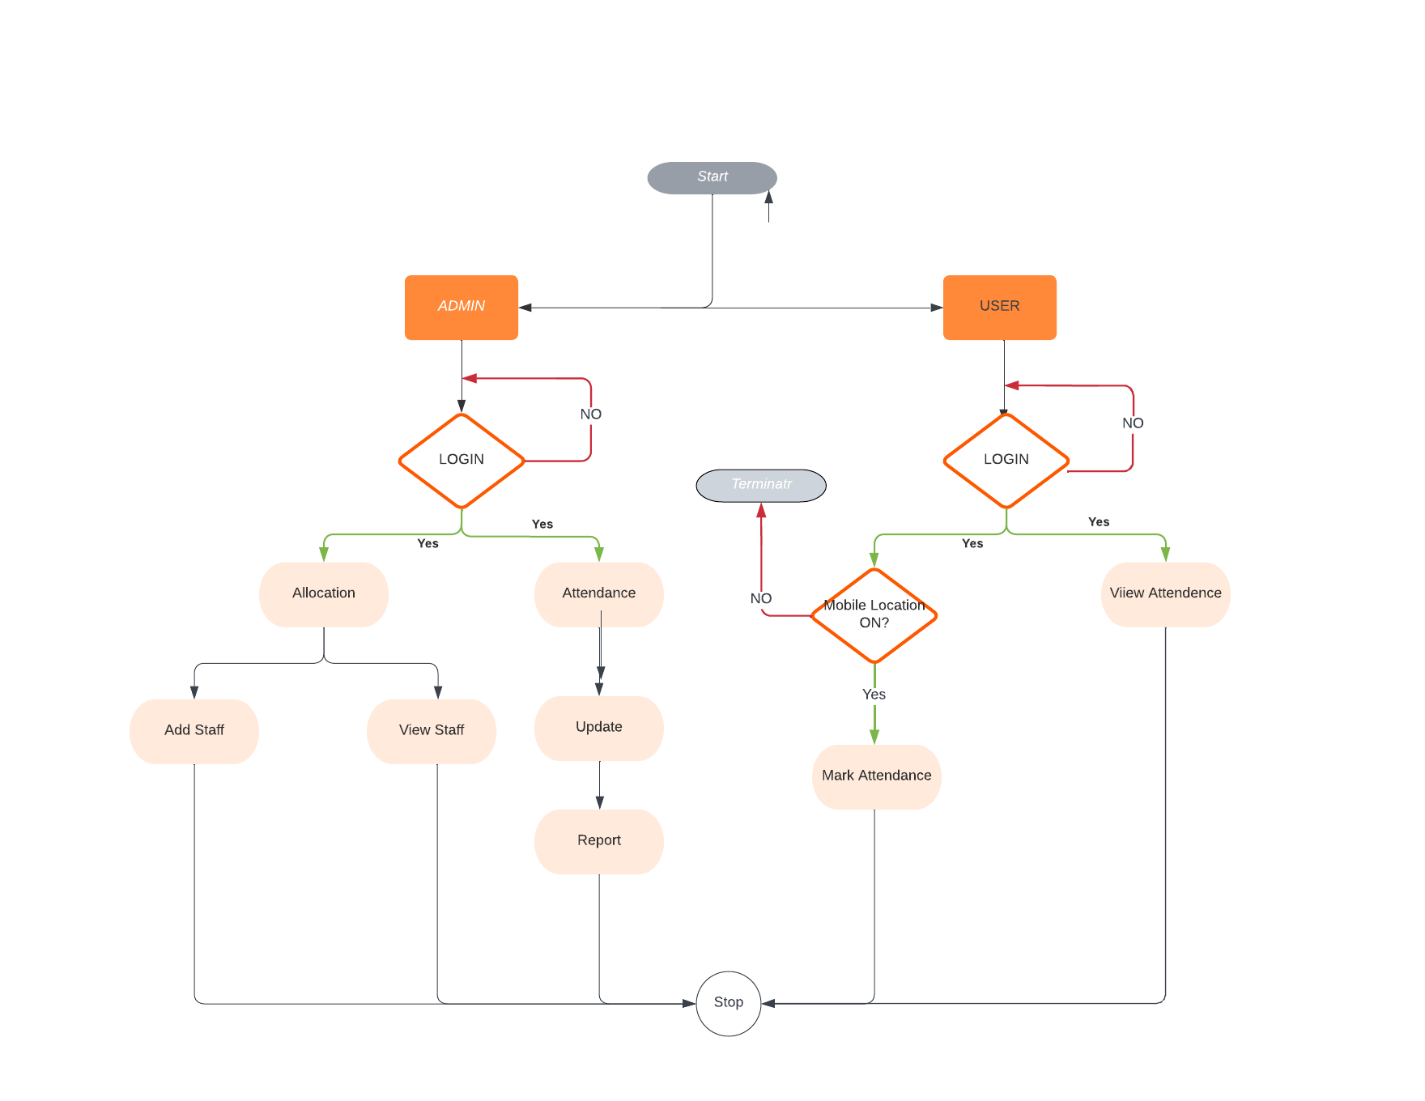
Figure SLA-1.0

  - Sub-System / Component / Module Level Architecture
The sub-system includes the detail about teacher login, admin login, and how teacher marks their attendance. It has the following details

- Every teacher will be registered.
- The teacher added a new member
- The teacher will receive a unique id to log in to the system.
- The teacher will be able to mark attendance.
- The teacher will have daily attendance.
- The teacher will ask for access.
- The teacher will be able to view attendance.
- The report will be provided to the administrator.

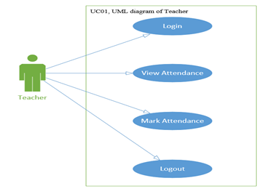

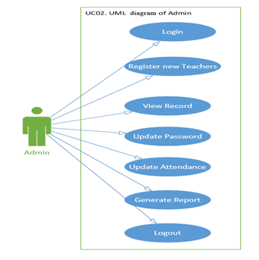
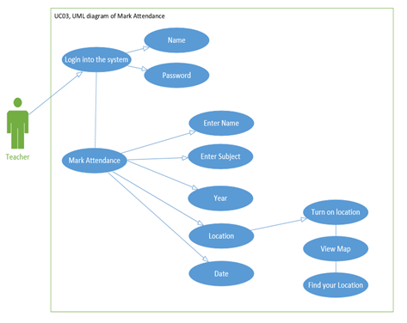

Design Strategies
Describe the design strategies or decisions that impact the overall organization of the system and its high-level structures. This information should provide the reader with insights into the key abstractions and mechanisms used in the system architecture.

  - Strategy 1
Future system extension or enhancement
Online Attendance System is a software developed for daily attendance in colleges and institutes. Although AMS the system is good for teachers based on their criteria preferences, future work can be considered to enhance the system even more. The future work later on below:
- The project is developed as an android application, and it will work for a particular institute. But later on, the project can be modified to operate on windows.
- In the future, we can add biometrics for better verification of users.
User interface paradigms
In this application, the user interface is built using View and View Group objects. There are many types of views and view groups, each of which is a descendant of the View class. View objects are the basic units of user interface expression on the Android platform. This application is the graphical and \touch-sensitive display on a mobile device that allows the user to interact with the device's apps, features, content, and functions.
Data management (storage, distribution, persistence)
For normal apps, there are stored in the internal memory in /data/app. In some of the encrypted apps, the files are stored in /data/app-private. For apps stored in the external memory, files are stored in /mnt/sdcard/Android/data. In the development phase, we will use internal memory for storage.
The database we will use will be Firebase Real-time Database, which is a cloud-hosted NoSQL database that lets us store and sync data between our users in real time.
Concurrency and synchronization
An attendance management system, it will allow multiple users to mark attendance at the same time and allow multiple users to affect multitask tasks within the database. The ability to offer concurrency is unique to databases.

Detailed System Design
A detailed design should include the following:
- Admin
- Teacher
- Course
- Attendance Report
- Teacher Attendance
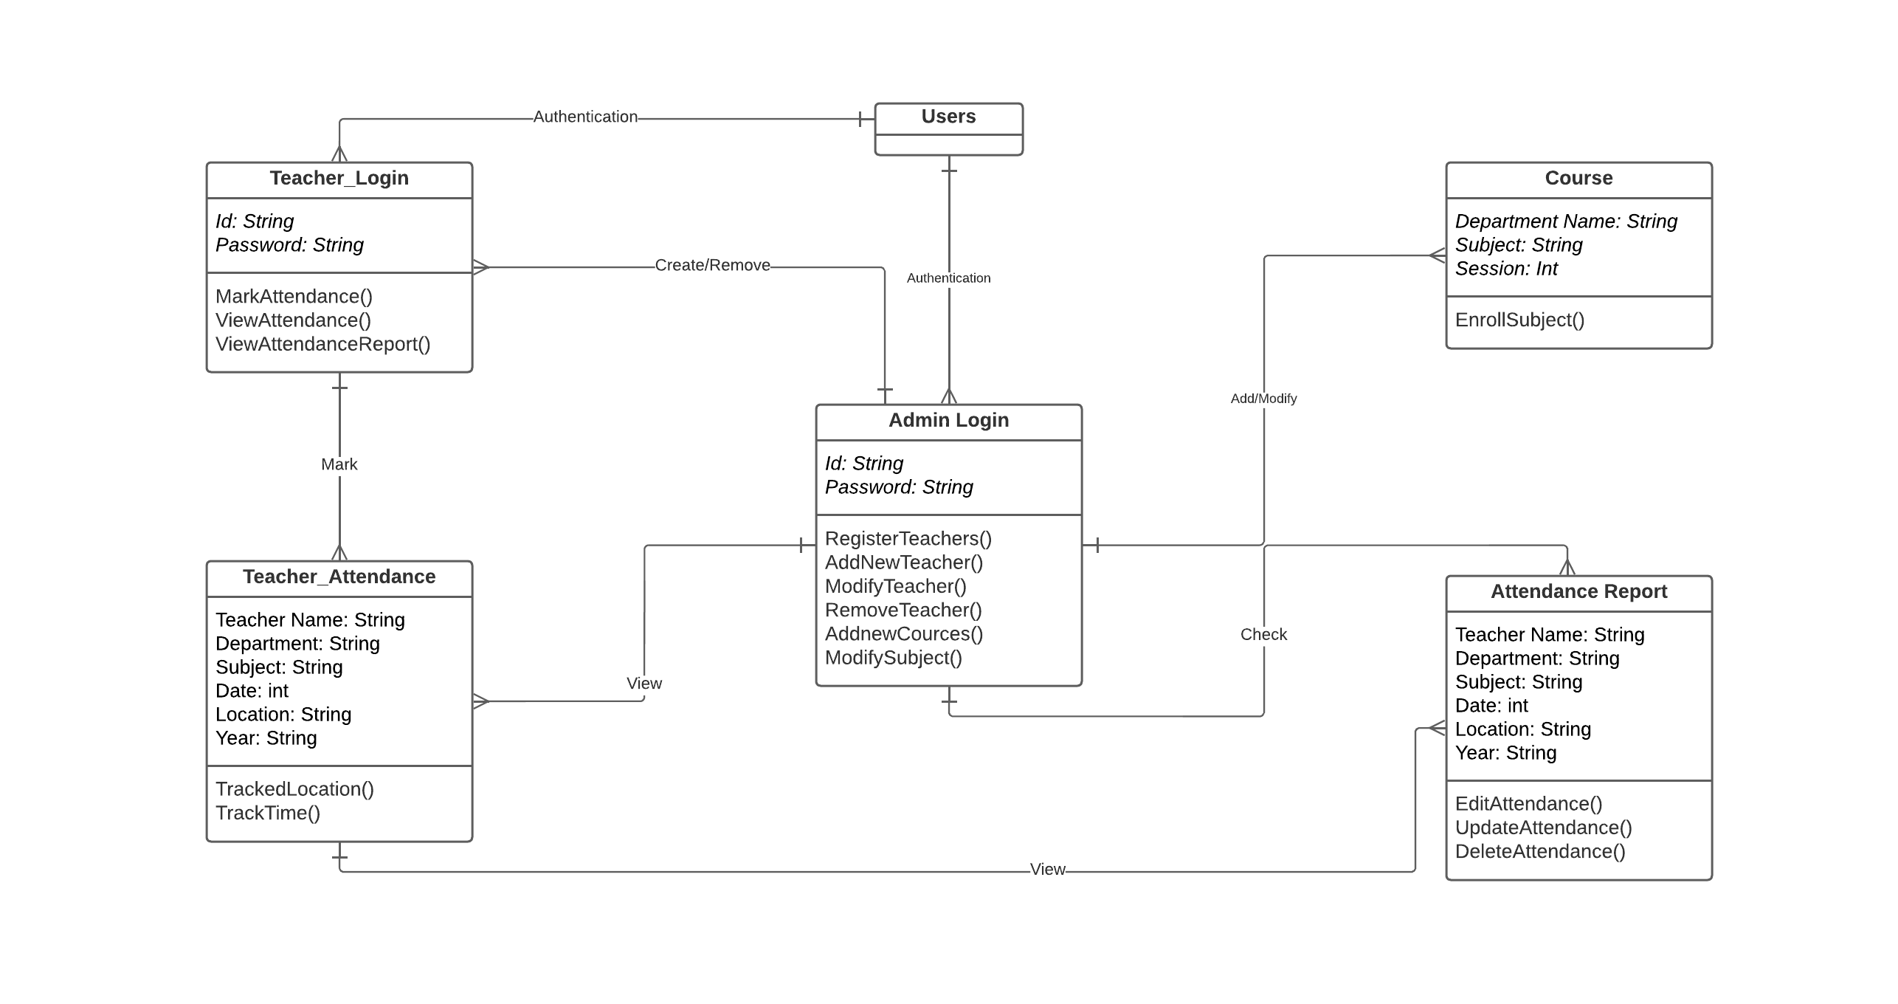
Figure SLA-1.0

- class (Admin)
Attributes/Variables of the class (Admin)
Private Attributes/Variables:
There are the following private attributes in the mentioned class diagram.
-Id: String
-Password: String
Public Attributes/Variables:
There are the following public attributes in the mentioned class diagram.
Nil
Functions of the class (Admin)
Private Functions:
There are the following private functions in the mentioned class diagram.
-RegisterTeachers()
-AddNewTeacher()
-ModifyTeacher()
-RemoveTeacher()
-AddnewCources()
-ModifySubjects()
Public Functions:
There are the following public functions in the mentioned class diagram.
Nil

- class (Teachers)
Attributes/Variables of the class (Teachers)
Private Attributes/Variables:
There are the following private attributes in the mentioned class diagram.
-Id: String
-Password: String
Public Attributes/Variables:
There are the following public attributes in the mentioned class diagram.
+Id: string
Functions of the class (Teachers)
Private Functions:
There are the following private functions in the mentioned class diagram.
- MarkAttendance ()
-ViewAttendance ()
-ViewAttendanceReport ()
Public Functions:
There are the following public functions in the mentioned class diagram.
Nil

Class(Courses)
Attributes/Variables of the class (Courses)
Private Attributes/Variables:
There are the following private attributes in the mentioned class diagram.
Nil
Public Attributes/Variables:
There are the following public attributes in the mentioned class diagram.
-Department Name: String
-Subject: String
-Session: Int
Functions of the class (Courses)
Private Functions:
There are the following private functions in the mentioned class diagram.
Nil
Public Functions:
There are the following public functions in the mentioned class diagram.
EnrollSubject()

- class (Attendance Report)
Attributes/Variables of the class (Attendance Report)
Private Attributes/Variables:
There are the following private attributes in the mentioned class diagram.
- Teacher Name: String
-Department: String
-Subject: String
-Date: int
-Location: String
-Year: String
Public Attributes/Variables:
There are the following public attributes in the mentioned class diagram.
Nil
Functions of the class (Attendance Report)
Private Functions:
There are the following private functions in the mentioned class diagram.
- EditAttendance ()
-UpdateAttendance()
-DeleteAttendance()
Public Functions:
The functions in the mentioned class diagram. Nil
- class (Teacher_Attendance)
Attributes/Variables of the class (Teacher_Attendance)
Private Attributes/Variables:
There are the following private attributes in the mentioned class diagram.
-Name: String
-Department: String
-Subject: String
-Location: String
-Year: int
-Date: int
Public Attributes/Variables:
There are the following public attributes in the mentioned class diagram.
Nil
Functions of the class (Admin)
Private Functions:
There are the following private functions in the mentioned class diagram.
-TrackedLocation()
-track time ()
Public Functions:
There are the following public functions in the mentioned class diagram.
Nil

State Transaction Diagram
The designed sequence diagram for the attendance management system gives you the exact scenario when the project is in use. This design presents the actual sequence of events and interactions between the user and the project. It uses symbols to represent the included objects and their roles in the attendance management system sequence diagram.
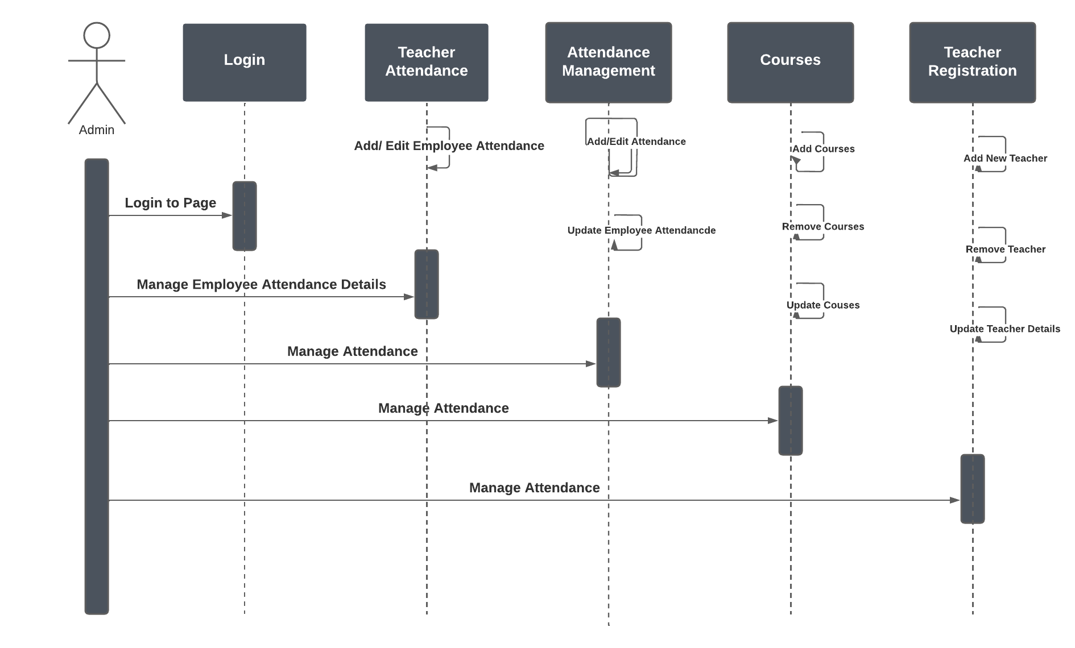
Figure ST-1.0

Figure SLA-1.0

The illustration is based on the main process of the attendance management system. It can still be modified and added to your desired functions and scenario. It is more effective and efficient to manage and monitor the attendance of employees through the attendance management system.

Sequence Diagram
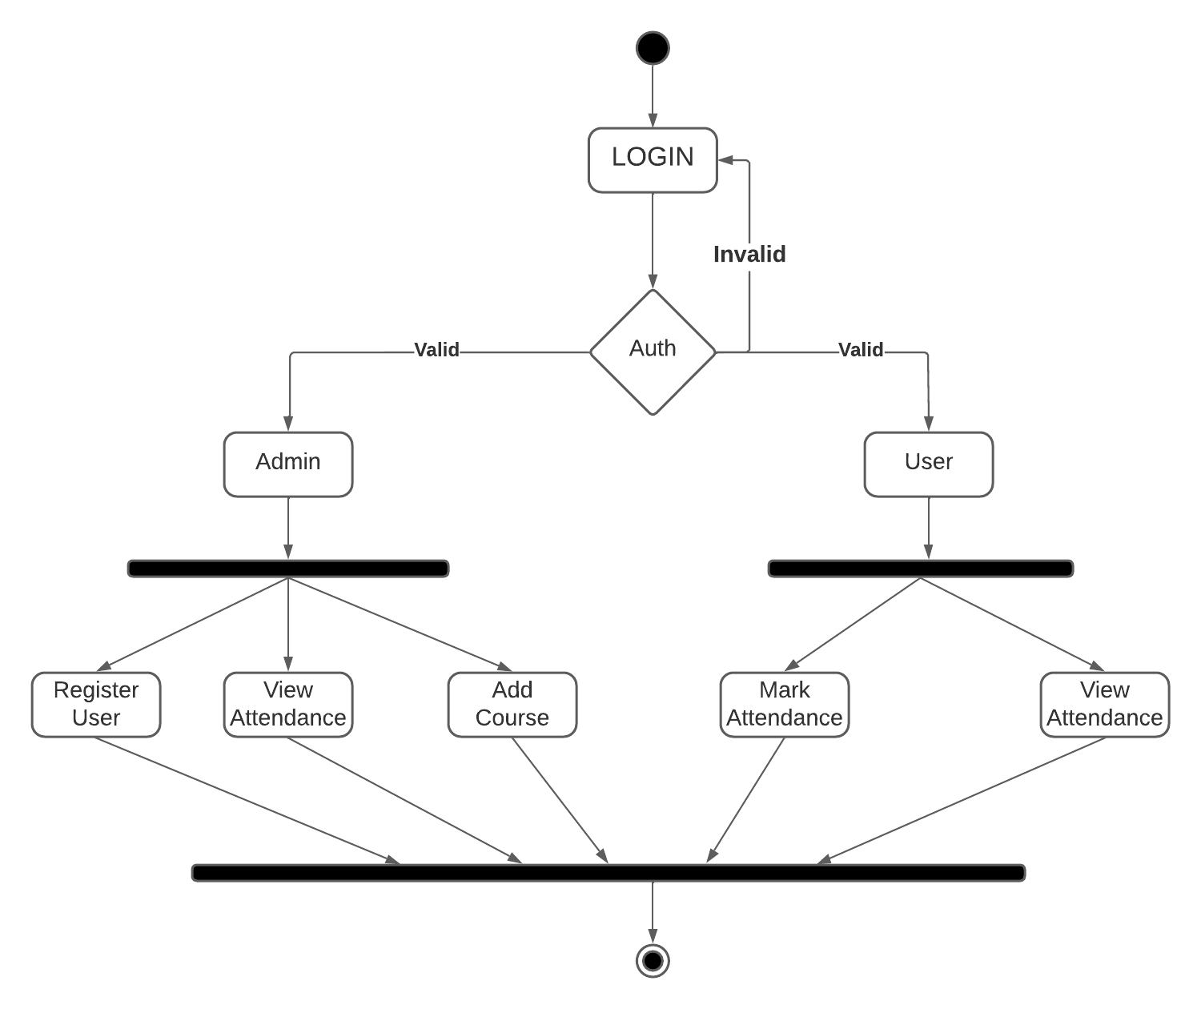
Figure SD-1.0

Logical Data Model (E/R model)
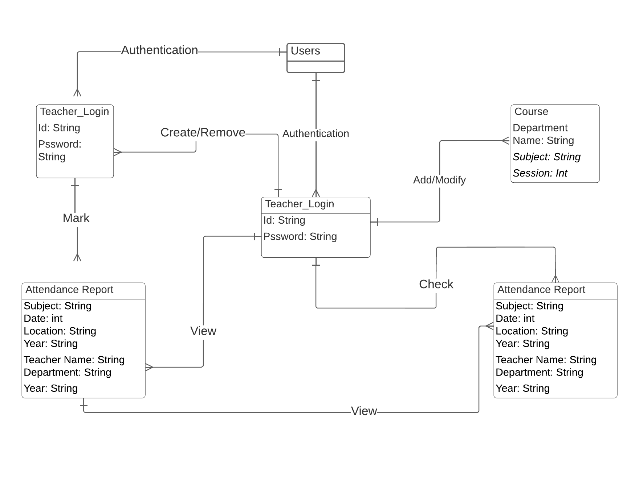
Figure LDM-1.0
Figure SLA-1.0

Figure SLA-1.0

Physical data models
Context Level
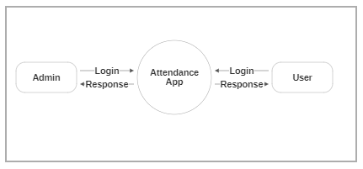
Figure PD-1.0
Figure LDM-1.0
Figure LDM-1.0
Admin- Data Flow Diagram Attendance Management System

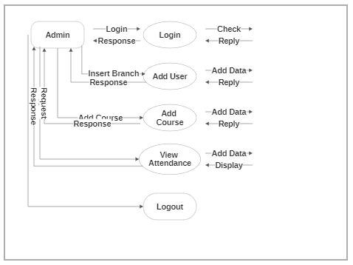
User- Student Side Data Flow Diagram Attendance Management System
Figure PD-1.1

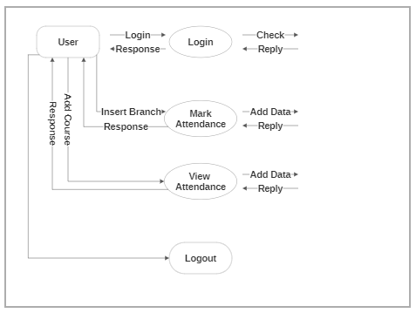
Figure PD-1.2

Detailed GUIs
Splash Screen Login page
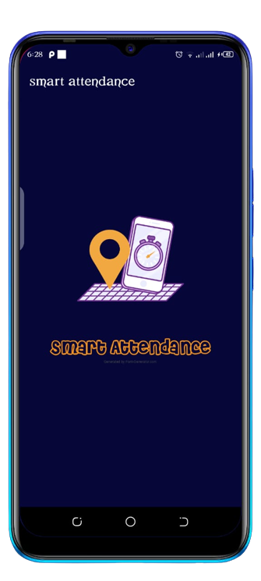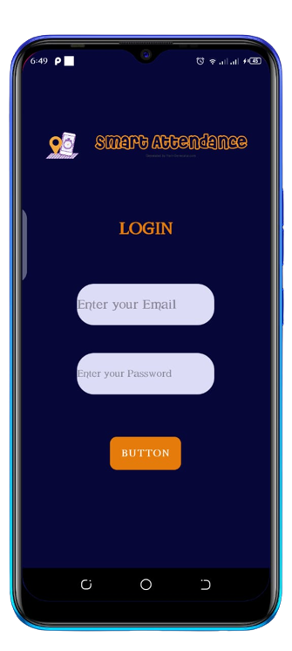
Figure GU-1.1
Figure GU-1.0

The first page which will appear on the app will be a Splash screen with a duration of five or less than five seconds, the user (either its admin or teacher) login to the system and the teacher will access the page to mark attendance and the admin will go to its page. The teacher will be able to access the attendance app only if the admin has registered the faculty member.
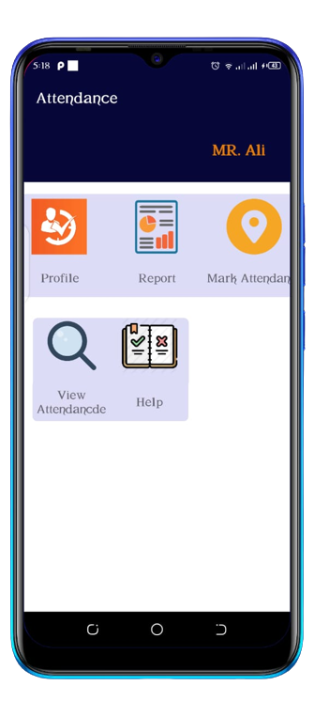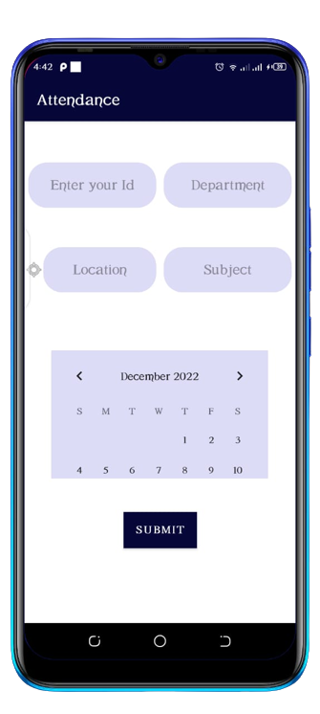
Figure GU-1.2
Figure GU-1.3
User side Attendance

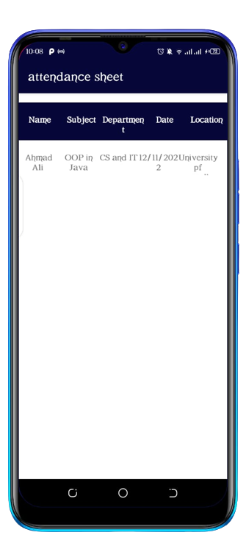
Figure GU-1.4

Admin Side Teacher Registration
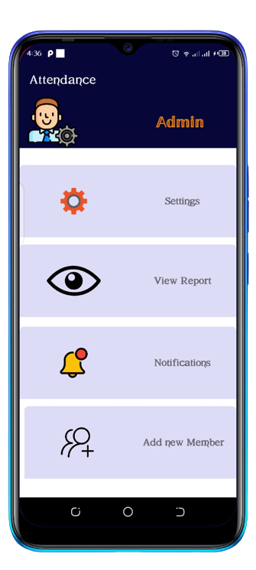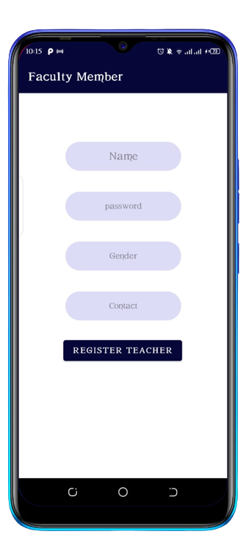
Figure GU-1.6
Figure GU-1.5

References
This section should provide a complete list of all documents referenced at a specific point in time. Each document should be identified by title, report number (if applicable), date, and publishing organization. Specify the sources from which the references can be obtained (This section is like the bibliography in a published book).

Ref. No. | Document Title | Date of Release/ Publication
PGBH01-2022-Proposal | Project Proposal | Oct 11, 2022
PGBH01-2022-FS | Functional Specification | Nov 15, 2022

